UNCLASSIFIED External

# A-NZ PEPPOL FRAMEWORK GUIDANCE NOTE

## Routing invoices to the desired receiving system

**Guidance note** [#]

|  |  |  |
| --- | --- | --- |
| **Issue date** |  | **Version** |
| XX Month Year |  | 1.0 |
| **Operative From** |  | **Artefacts affected** |
| Month Year |  | NA |

#### Introduction

PEPPOL’s ‘four corner model’ allows suppliers to invoice buyers that are connected to the PEPPOL network. This is achieved by looking up the buyer’s electronic address using the appropriate Peppol participant ID.

There are a variety of business management tools for both small and large businesses (such as for asset management, travel management, or labour hire management) that buyers (corner 4) use to manage procurement and accounts payables. Additionally, large businesses often have several segregated business units, each operating their own invoicing system. This adds complexity for buyers to manage inbound invoices to ensure they arrive at, and processed by, the correct system.

#### Issue Statement

Peppol uses the Service Metadata Locator (SML) and Service Metadata Publisher (SMP) to enable invoice senders (suppliers) to look up receivers’ (buyers’) address and capability.

Each ‘message receiver’, i.e. corner 4, can have one or more Peppol participant IDs published in the SML, with each unique participant ID directing to a SMP that contains delivery details. This means that for each type of document (e.g. invoice or purchase order), each participant ID can only direct to one single delivery address.

Some buyers use multiple business management applications to manage different ‘types’ of procurement and require corresponding invoices to be sent to the appropriate business management application for matching/processing. An example is illustrated below.

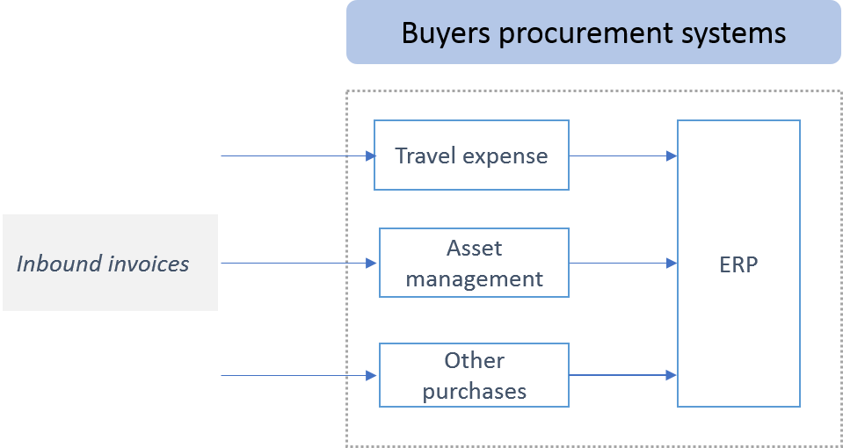

Figure 1 – a buyer using multiple expense management tools

### Guidance

There are two broad options to route inbound invoices to different applications.

1. **Separate Participant Identifiers for each invoice receiving application**
2. **A single Participant Identifier exposed with internal routing to the correct application on the buyer’s side (C4)**

Note: A combination of both options may be the best solution for some businesses.

The two options are illustrated below in the Peppol context.

**Option 1 - Separate Participant Identifiers for each invoice receiving application**

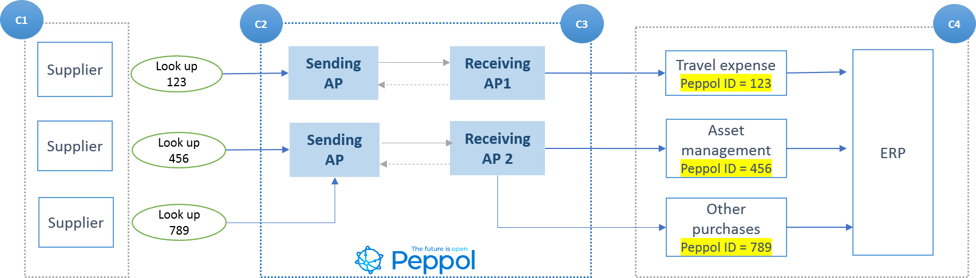

Figure 2 – a buyer registers each ‘receiving application with a unique Peppol ID

This is the easiest technical solution however C4 businesses will need to consider business impacts and user experience issues. This is particularly the case in Australia and New Zealand where the default user experience for suppliers is to use the ABN or NZBN.

**Pros**

* Invoices are delivered to the desired application directly
* Flexibility for C4 to use different service providers
* No complex integrations required for C4, between different internal systems/applications

**Cons**

* Effort required for supplier on-boarding, to ensure they use the appropriate identifier when sending invoices
  + Some suppliers will need to use other identifiers (rather than ABN/NZBN) to trade with the buyer.
  + There is a risk that some suppliers may send invoices using incorrect identifiers (particularly to the ABN/NZBN) and as a result delivering invoices to incorrect applications.
* Cost of maintaining multiple Access Points and Identifiers.

**Option 2 - Single Participant Identifier exposed with internal routing capability within buyer’s side**

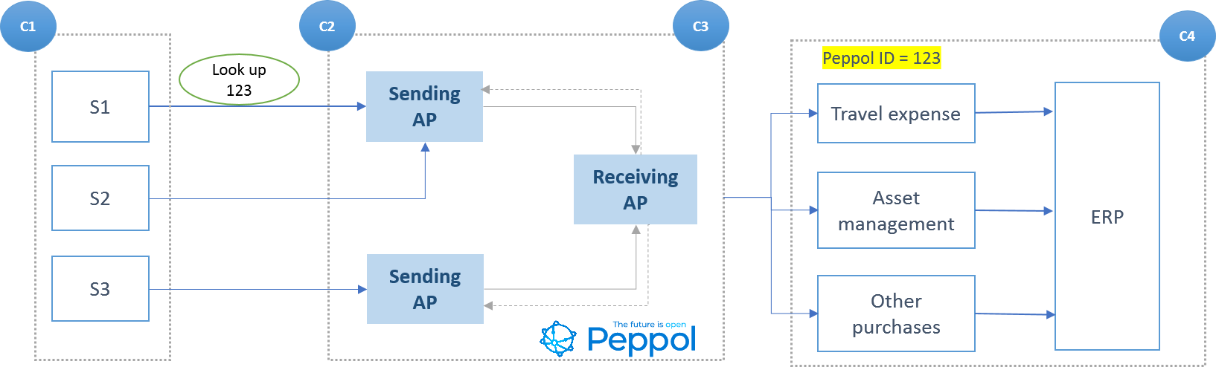

Figure 2 – the buyer uses one Peppol Access Point to receive all invoices and route internally

**Pros**

* Simpler supplier experience (uses ABN/NZBN as the default identifier)

**Cons**

* Build effort to enable routing between multiple C4 applications.
* Supplier on-boarding effort still required to ensure suppliers provide adequate information to enable C4 to route an invoice to the right application.
* C4 can only use one Access Point provider to receive invoices (but can use a different Access Point for different documents, e.g. Order).

#### Recommendations

The following recommendations should be considered to achieve greater efficiency in managing and processing invoices.

1. Where practical, businesses should centralise their accounts payable functions and use an invoice management solution (i.e. automation) to manage the approval and processing of invoices.
2. Systems that only handle specific types of invoices (e.g. from a specific group of suppliers, or of specific industry/business requirements) should utilise other identifers (such as GLN or DUNS number). Common examples include travel management and labour hire, for which contracts/purchases and invoices are better managed by specialised application.

Receivers should endeavour to ensure only those invoices meant to be received by a specific-purpose system are sent to that system. All other invoices should be received into a general-purpose invoice management system (refer to Recommendation 1).

1. Where it is desirable to maintain multiple systems for inbound invoices the ABN/NZBN should be used for routing to the system that handles general, non-trade type invoices.

**Rationale:** There is likely to be a comprehensive supplier on-boarding process for trade suppliers. This will make it simpler to ensure they are provided with and use the correct identifier. For the non-trade side of the business, the relationship to suppliers are often more ad-hoc and transitory in nature. Given the default experience for most businesses will be to use the buyer’s ABN/NZBN to look up a buyer and send an invoice, this arrangement is more likely to ensure invoices are sent to the correct system.

1. Internal routing will mostly likely rely on invoice contents, such as Purchase order number and/or Vendor ID. This should be leveraged off the ‘Best Practice’ data elements listed in the [Industry Practice Statement on Invoice Content](https://github.com/A-NZ-PEPPOL/A-NZ-Industry-Practice-Statements/blob/main/A-NZ_Industry_Practice_Statment_%20Invoice_Content_v1.0.docx).
2. For internal routing to work effectively, the integration between systems should consider invoice response messaging. Businesses can either use a single system to manage all messaging with the Access Point or have multiple systems connect directly to the Access Point for send and response messaging.
3. Businesses must be prepared to handle invoices sent to the wrong location. Suppliers should be educated to send to the correct identifier where this occurs.

On an exception basis, buyers should have the capability to ‘route’ the invoice to the correct location, ideally using direct integration between their systems.

Consideration should be given to how buyers support [invoice response messaging](https://docs.peppol.eu/poacc/upgrade-3/profiles/63-invoiceresponse/) in this scenario.

**Version history**

|  |  |  |
| --- | --- | --- |
| **Version** | **Date** | **Change** |
| 1.0 | [date] | Initial published version |
| 1.1 | [date] | [describe change] |